Elior Bilow
Recitation 6 – LCM and 1D Transient
MEGN 471 – CSM
2022-03-09

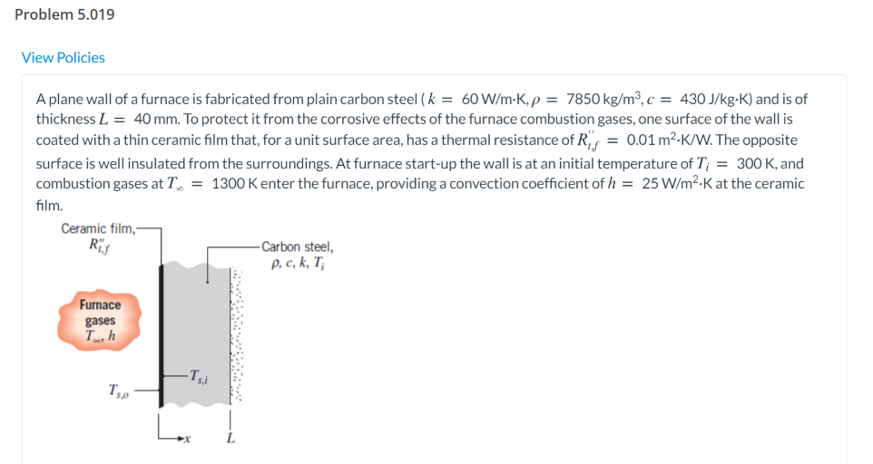

It’s summer and you’re grilling for your friends. How long should you cook them for?
You’re cooking brats and are turning them around frequently (assume uniform heating from all sides). The brats came out of the refrigerator and onto the grill at 4ºC. The safe temperature for pork is 71ºC (the center needs to reach that temperature). The grill is at 400ºC The convection coefficient on the brat is 200 W/(m²*K). You can approximate the properties of brats as the same as water (c_{p} = 4184 J/(kg*K), k = 0.598 W/(m*K)). They are approximately 2cm in diameter and 13cm long.
- What’s the Biot number? Is the lumped capacitance method (LCM) applicable?
- Do you need to find the Fourier number?
- How long should you cook the brats for?
- Did you burn the brats? (Is the exterior temperature of the brats over 260ºC.

It’s cold and you want to make chili. Unfortunately, the cold weather broke the wifi drones can’t fly in the high winds, so you don’t know how long to cook it for. However, you do have your knowledge of heat transfer to help you!
The chili should be cooked to 90ºC. You can approximate the heat capacity and thermal conductivity of food as the same as water. The crock pot you’re planning to cook the chili in is 25cm is diameter and 15cm deep. The crock pot draws 150W of power. The convective heat transfer coefficient h_{conv} can be approximated to 40W/(m²*K). The surrounding air is at 20ºC.
How long should you cook the chili for?
- What’s the Biot number? Is the lumped capacitance method (LCM) applicable?
- Do you need to find the Forier number?
- How long should you cook the chili for?

